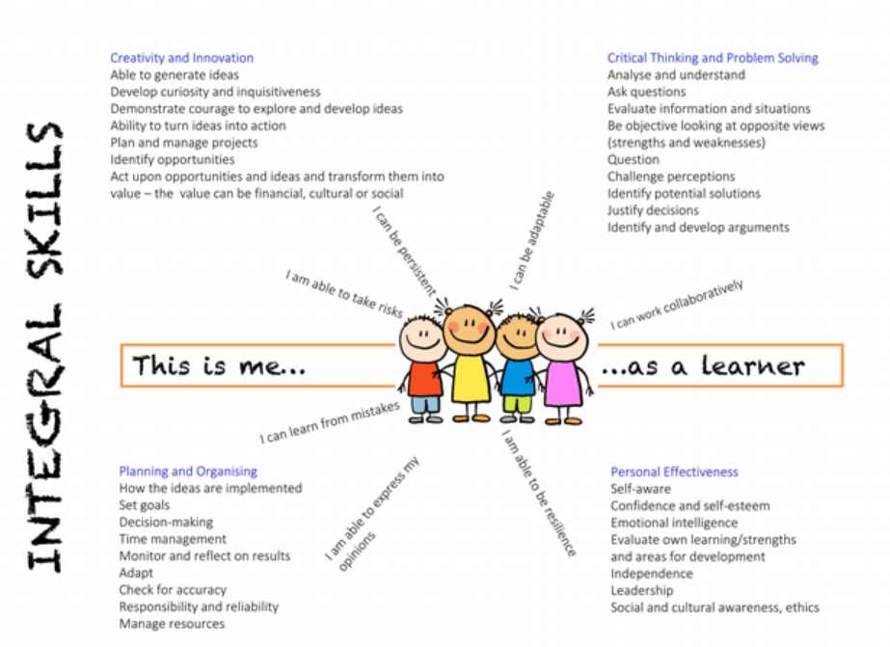

Skills integral to the four purposes
The four purposes are also underpinned by integral skills which should be developed within a wide range of learning and teaching.
These skills are noted below.

Creativity and innovation
Learners should be given space to be curious and inquisitive, and to generate many ideas. They should be supported to link and connect disparate experiences, knowledge and skills, and see, explore and justify alternative solutions. They should be able to identify opportunities and communicate their strategies. This should support learners to create different types of value.

Critical thinking and problem-solving
Learners should be supported to ask meaningful questions, and to evaluate information, evidence and situations. They should be able to analyse and justify possible solutions, recognising potential issues and problems. Learners should become objective in their decision-making, identifying and developing arguments. They should be able to propose solutions which generate different types of value.

Personal effectiveness
Learners should develop emotional intelligence and awareness, becoming confident and independent. They should have opportunities to lead debate and discussions, becoming aware of the social, cultural, ethical and legal implications of their arguments. They should be able to evaluate their learning and mistakes, identifying areas for development. They should become responsible and reliable, being able to identify and recognise different types of value and then use that value.

Planning and organising
Where developmentally appropriate, learners should be able to set goals, make decisions and monitor interim results. They should be able to reflect and adapt, as well as manage time, people and resources. They should be able to check for accuracy and be able create different types of value.

